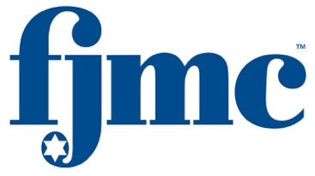

Dear Friends,

[Insert Honoree] has been chosen by the FJMC [InsertRegion] Region to receive the prestigious 2019 Ma’asim Tovim (Doer of Good Deeds) honor. The recognition will be made to [honoree First Name] by the region during the FJMC Biennial Convention, which will be held from July 3 thru July 7, 2019 at the Westin Harbor Castle, Toronto Canada.

This honor is the highest and most cherished that any region of the FJMC can bestow upon one of its members. The honor recognizes significant accomplishments the honoree has made to his club, his synagogue, and the Jewish community. [honoree First Name] joins a small, but growing, fraternity of dedicated volunteers whose efforts and actions have helped to improve our lives and the world we live in.

[honoree First Name]’s biography, along with a summary of his accomplishments, will be published in the 2019 FJMC Convention Journal. The journal is the vehicle we use to pay tribute to [honoree First Name] and the many other volunteers within the Federation of Jewish Men’s Clubs and its affiliated regions and member clubs. We encourage you to pay tribute to [honoree First Name] via the purchase of an ad in the 2019 FJMC Convention Journal in [honoree First Name]’s honor. Tribute price categories range from $54 for a listing, up to $5,000 for a Platinum Sponsorship. All tribute categories and prices are defined in the FJMC web site www.fjmc.org, and on the attached sheet. Revenue from the convention journal helps the FJMC to continue to fund new initiatives and provide essential services to the member clubs.

We have known [honoree First Name] for many years and he is well deserving of this honor. Please join me in paying tribute to [honoree First Name] and his volunteerism by purchasing a tribute in [honoree First Name]’s honor. Tributes can be placed at journal@fjmc.org

Thank you in advance for your generous support.

Respectfully yours in Brotherhood,

[Joe Solicitor]
[InsertRegion] Region Ad Chairman

Steve Lessman and David Goldis
FJMC Ma’asim Tovim Awards Chairs

Joey Swerdlow and Steve Krodman
FJMC Convention 2019 Chairs

