Budapest, Hungary and Temple Israel (Sharon, Mass) Brotherhood Collaboration

For the past year the Brotherhood of Temple Israel (TI)of Sharon, Massachusetts and Dor Hadash of Budapest have been collaborating on a project to help both communities learn, grow and enrich one another.
Dor Hadash is a small (30-40) egalitarian Masorti community, consisting primarily of young professionals or those pursuing graduate studies. They have been meeting in a community center to celebrate Shabbat and the holidays for several years. This community is the early stages of its Jewish development. Masorti Europe has assisted with rabbinical oversight and the provision of religious objects, but most of the work has been done by the group on its own.
Through monthly Skype calls, Temple Israel’s Brotherhood has connected with a few of the leaders of Dor Hadash. The Hungarian Jewish community is under pressure due to the resurgence of both anti-semitisim and racial bigotry that has gained momentum politically and is exacerbated by a poor economy. By staying “connected” the TI Brotherhood is sending the message that the Hungarian community is not alone.
In February the two communities simultaneously celebrated a unique event- the Worldwide Wrap. Connected via Skype on the big screen, Rabbi Barry Starr gave a d’var on the meaning of the tefillin and this was followed by the communities davening together. Approximately 7 of the Budapest community and 70 of Temple Israel participated. A powerful moment for all was when two former Hungarian survivors of the Holocaust who reside in Sharon spoke briefly about their joy at being able to share this experience.
Plans have been laid to have members of Temple Israel’s Brotherhood teach davening and Torah laining via the internet. This is intended to be an ongoing activity and other teaching/learning opportunities are contemplated. Temple Israel invited 2 of Dor Hadash’s leaders to join the Brotherhood at the FJMC convention and visit Sharon post-convention to meet the Temple Israel community and have a joint educational program. This will take place on July 29. In the future, it is anticipated that members of the Temple Israel Brotherhood will visit Dor Hadash in Budapest.

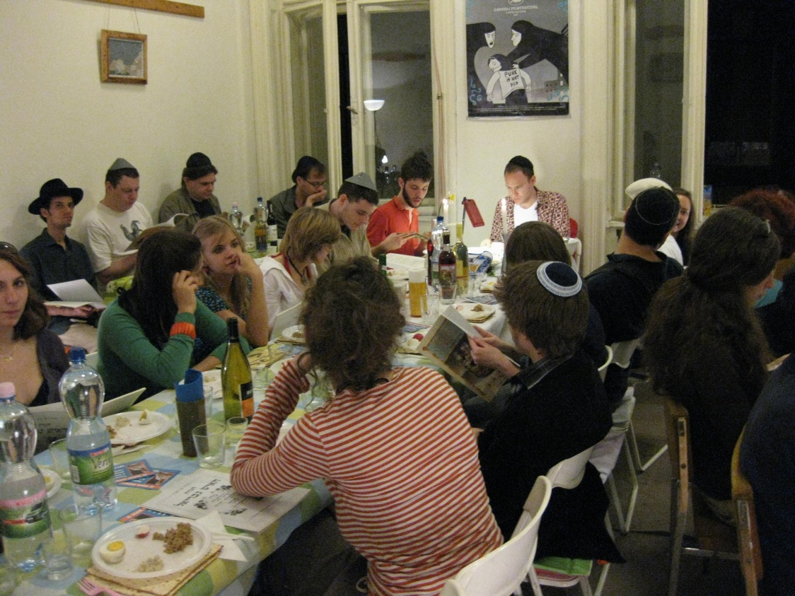

Mark Popovsky
Ron Czik
Temple Israel Brotherhood

